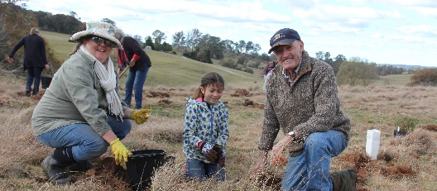
Kanangra-Boyd to Wyangala Link
Paddock Tree Recovery

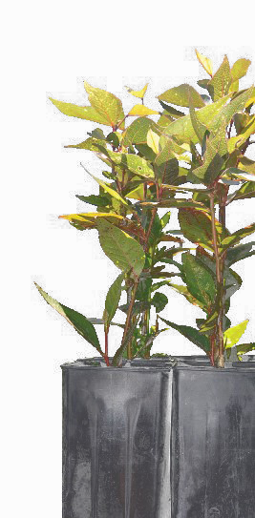
The Kanangra-Boyd to Wyangala Link (K2W) Glideways program has funding available to assist farmers within the Abercrombie River Corridor (see map) to replace native trees and shrubs that have been lost due to drought, senescence, and the recent bushfires.
- We will fund up to $3.75 (ex GST) per stem (including plant and guard) up to a maximum of $2500 per property.
- The project will only fund native trees and shrubs and all work will need to be completed before end of May 2021.
- All successful applicants will enter an agreement with the Foundation for National Parks & Wildlife and will be required to submit a report at completion of project.
- Projects much be located within the K2W corridor (see map below)
- To be eligible for funding Expression of Interest must be received before 30 June 2020

Map of K2W
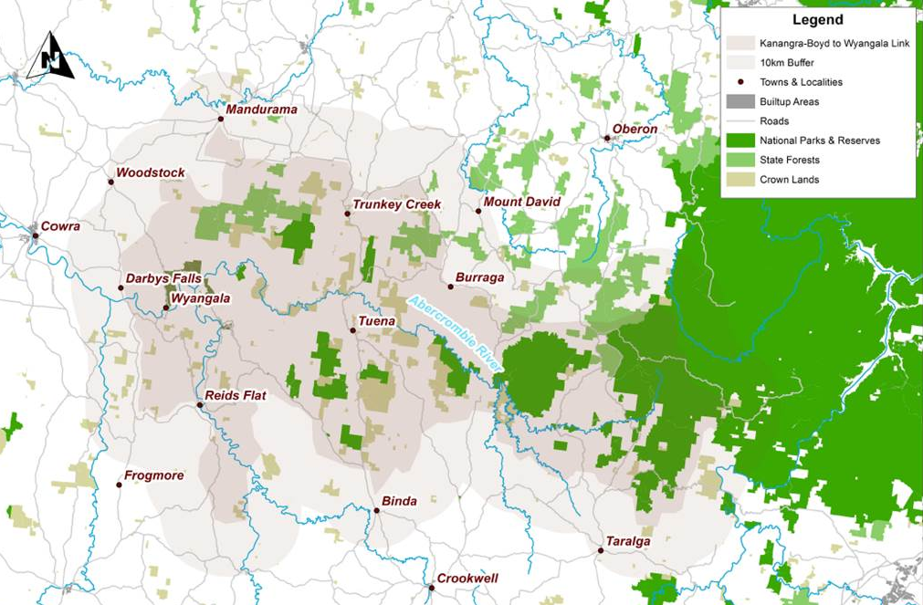

Expression of Interest

Please return your completed application form before 30 June 2020
mary@glideways.org.au | Mary Bonet, K2W Glideways,  Level 1 56 Clinton Street Goulburn NSW 2580

Name :
Address :
Contact Number : |  | Email :
Property Address :
- Lots and DP numbers :

Project Description

Please provide outline of the project including location; numbers of trees/shrubs required, a mud map, site plan or photograph(s) of site, and GPS coordinates (if possible)
Project Budget (ex-GST)

Activity | Landholder Contribution | Funds requested | TOTAL
 | AUD  AUD  AUD  AUD  AUD  AUD | AUD  AUD  AUD  AUD
TOTALS |  | AUD  AUD  AUD  AUD
AUD
AUD
AUD
AUD
 | Yes | No
Are you interested in undertaking other revegetation, habitat protection and restoration activities on your property if funding was available?
Are you interested in getting advice on managing habitat on your property?

Signed: _______________________________________ | Date: ______________
Name: _______________________________________
Restoring the “Glideways” of the K2W Link is supported by the Foundation for National Parks & Wildlife and the NSW Environmental Trust Bushconnect program.

